Fashion store

Web programming class project 2020/2021

|  |  |  |  |  |
| --- | --- | --- | --- | --- |
| Student Name in English | Student Name in Arabic | Student ID | Section | Work percentage |
| Omar Nasser Hussain dere | عمر ناصر حسين ديري | 11821073 | 11-12.30(2) | 50% |
| Ataa ali zohdi shaqour | عطاء علي زهدي شقور | 11820064 | 11-12.30(2) | 50% |
|  |  |  |  |  |

Date/time

---------------------------------------------This section is intended for the Instructor---------------------------------------

|  |  |
| --- | --- |
| **Topic** | **Mark** |
| Project Idea |  |
| Project Complexity |  |
| Project Tools |  |
| Project Requirements and Modeling |  |
| Project Discussion |  |
| Project Completeness |  |
| Project Output Results or reporting |  |
| Project Administration and Management |  |
| Project Report |  |
| Team work |  |
|  |  |
|  |  |
|  |  |
|  |  |
|  |  |

|  |  |
| --- | --- |
| Topic | Page number |
| Abstract | 3 |
| Introduction | 3 |
| Project Requirements | 4 |
| Tools used in the project | 5 |
| UML | 5 |
| Discussion about project GUI | 6-21 |
| Conclusion | 21 |
| References | 22 |

**Abstract:**

After the Covid-19 spread around the world, the number of peoples who do shopping on-line are increased. So I and my partner thought that its a good idea to build a website that make it easy to communicate between the customer and the shop-center online. If a person want to buy clothes, shoes, etc., he searches for what he need through our website.

**Introduction:**

The Fashion store website It helps people to do shopping online.

The user can send a feedback message to the admin to inform him of any notes on the site or on any product and The user can see the products available in the store and know all the details about them in terms of their price, available quantity and sizes .And if he likes the product, he can add it to the cart. He can also add more than one product to the cart.

The cart contain products that the user has selected. The user can also select the quantity he needs and buy it. When the purchase is made, the purchase order goes to the admin, who in turn prepares the order and delivers it to the user.

On the administrative side, the admin can add products to the site or delete products from the site in the event that they are no longer available in the store, and he can also modify the products offered in terms of their quantity, price, or other details.

There is also a page that displays the user's feedback messages and a page that displays the orders that users have purchased, which enables him to view a chart of sales per month.

**Project Requirements:**

This website talks about a fashion store to let the manager of the store organize the sell operations. And, to let people see his products such as clothes, shoes, and so on and allow users to do shopping online.

You can login to website as admin or user , the user contains **fname, lname, unique email, gender, password, City, address and Birthdate** , the admin ( store manager)same as user but contains a specific email**(fashion_store@gmail.com)** and specific password(**admin**).

Our web site contains **About Page, which contains information about the store**. and **Contact Us Page, which contains the email and telephone of the store** and box to make the user write a feedback about the store. This box contains**(full name ,email and your message)** the person can write many feedback messages.

Also, our website contains a home page , which contains **Items that have** a **name, size, unique ID, categories, Image, Price and Quantity.** The customer can add any item to the cart. Then, after selecting the products if he logged in he can buy it. if he doesn't he must log in first or sign up if he doesn't have an account.

Finally , When the user purchases the item the order of the purchase is sent to admin , the **order** contains **item_id ,unique order_id , user_email, dates ,quantity** .

**Tools used in the project:**

1. Php storm
2. Xampp 6
3. Many language and library as:

A- php

B- javascript

C- html5

D-CSS3

E-MySQL

F-charts js

G- Google fonts

## H- Awesome Icons

## UML:

## uml.png

**Discussion about project GUI:**

**USER SIDE:**

**At the beginning, when the user enters our website. the home page will appear as the following photo:**

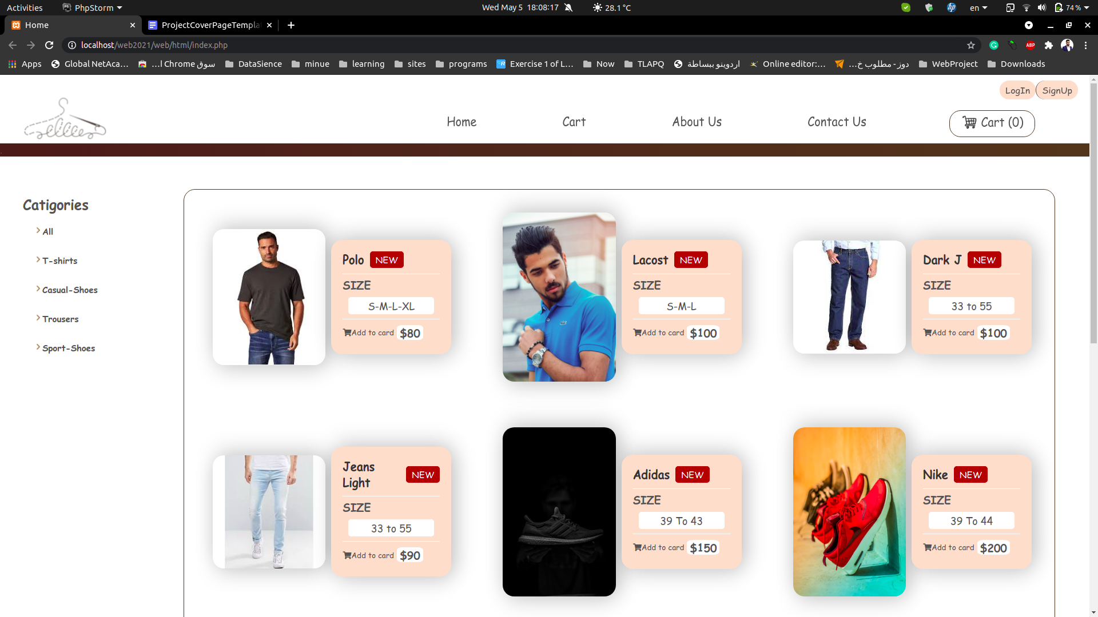

**the Home-page contains a header that contains a menu bar to make it easy for the user to transfer between the pages. and Categories to let the user choose a specific group of items, the last thing is Item container which contains the the related items that chosen from the category(all items will appear by default).**

**If he want to display just th T-shirt items :**

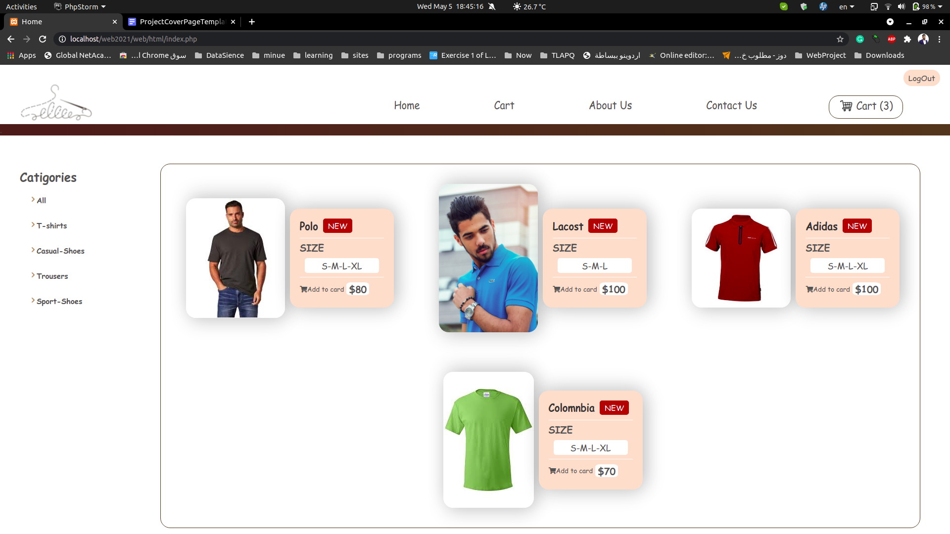

**The user can choose the item that he want to buy by clicking on (Add to Cart). Then, An alter will appear to notify him that the item was added**

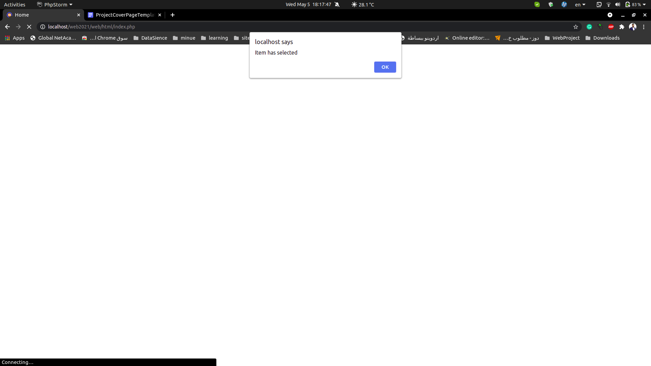

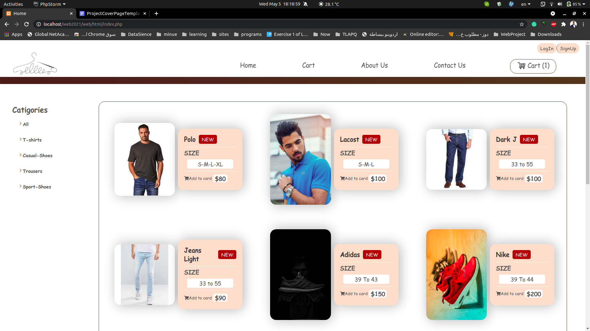

**The item will go to the cart. And the cart in the menu bar will increase by 1.**

**When he finished from choosing the items. He will go to the cart .**

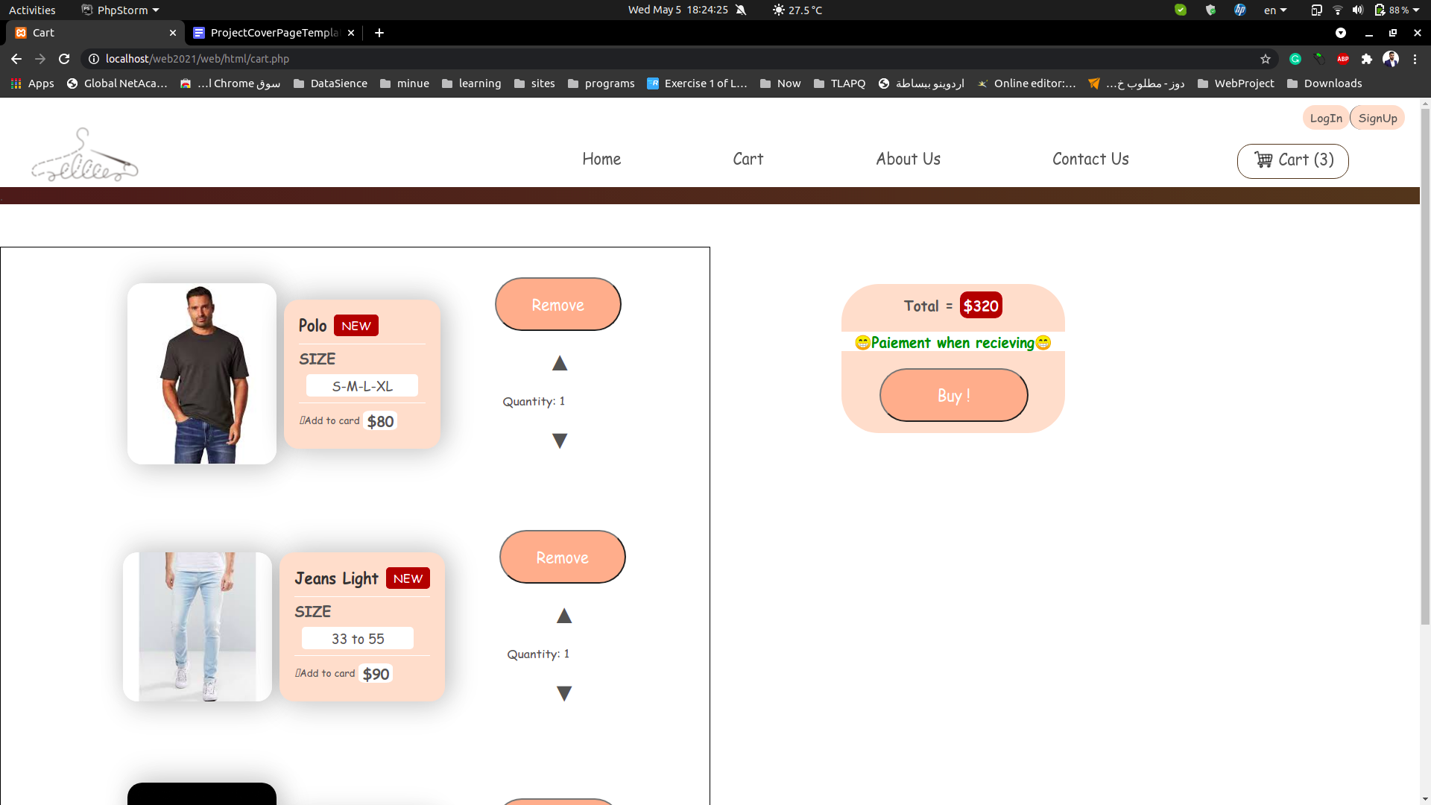

**He can increase the quantity of the item. At the same time, the total price will change according to the quantity.**

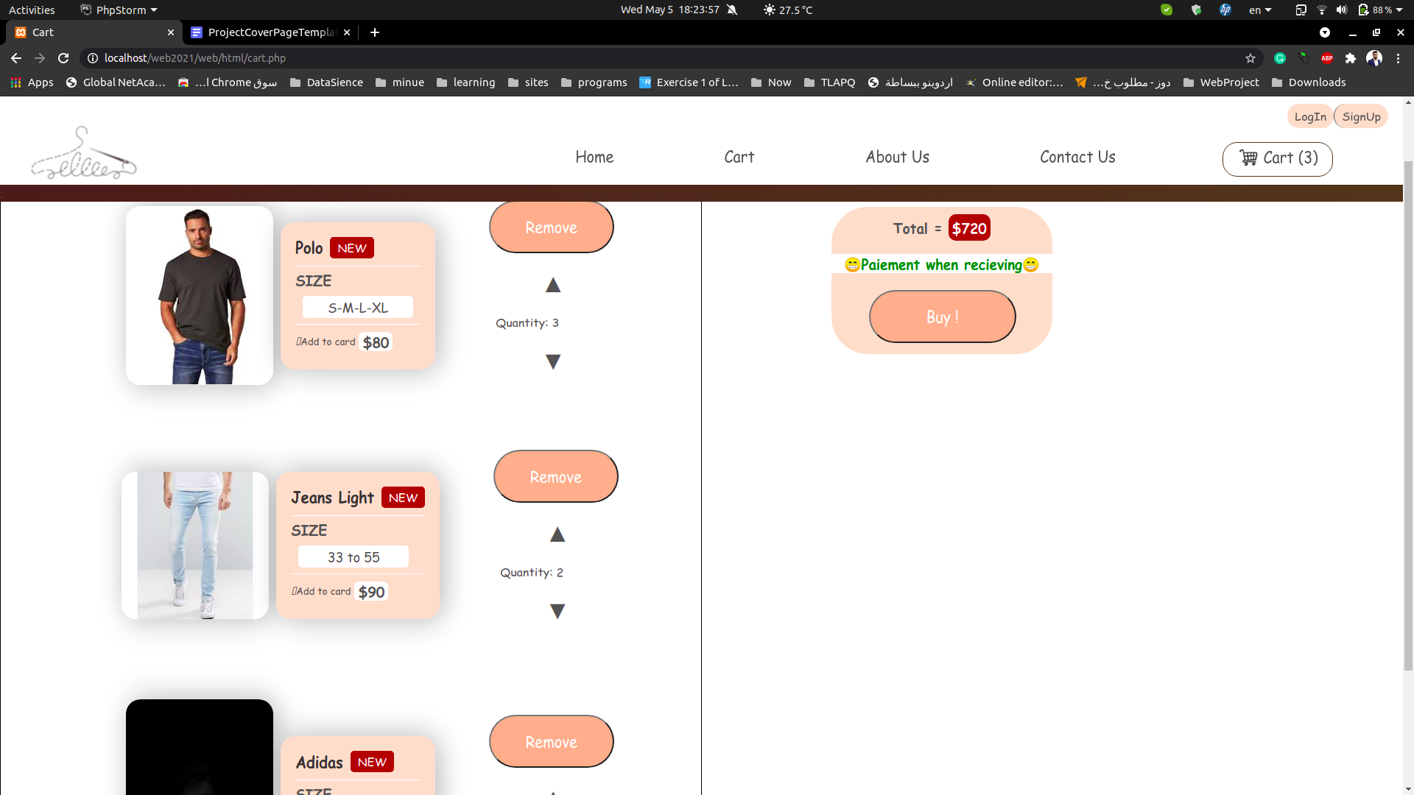

**Then, he clicks on buy to complete the buy operation.**

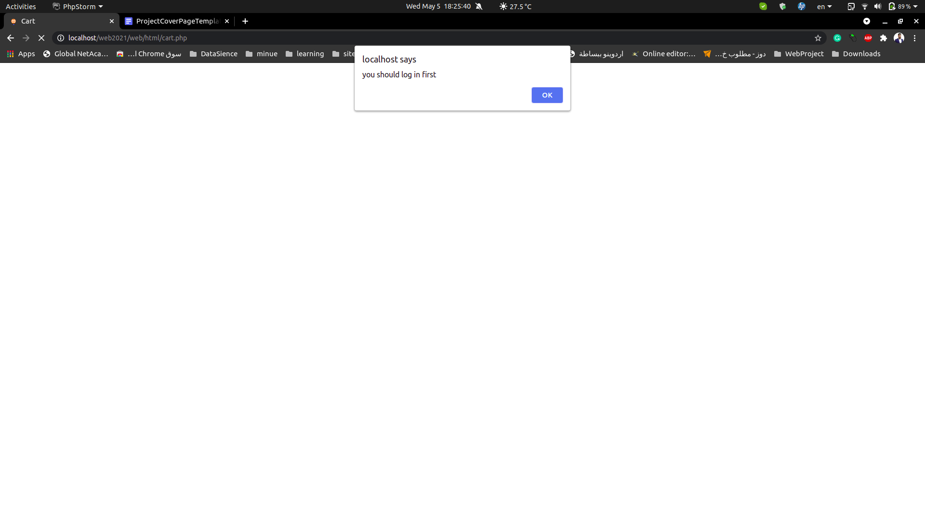

**OPPS… this alert appeared because he didn’t log in, so he must be logged in to complete the buy operation.**

**If he hasn’t an account he can sign up here.**

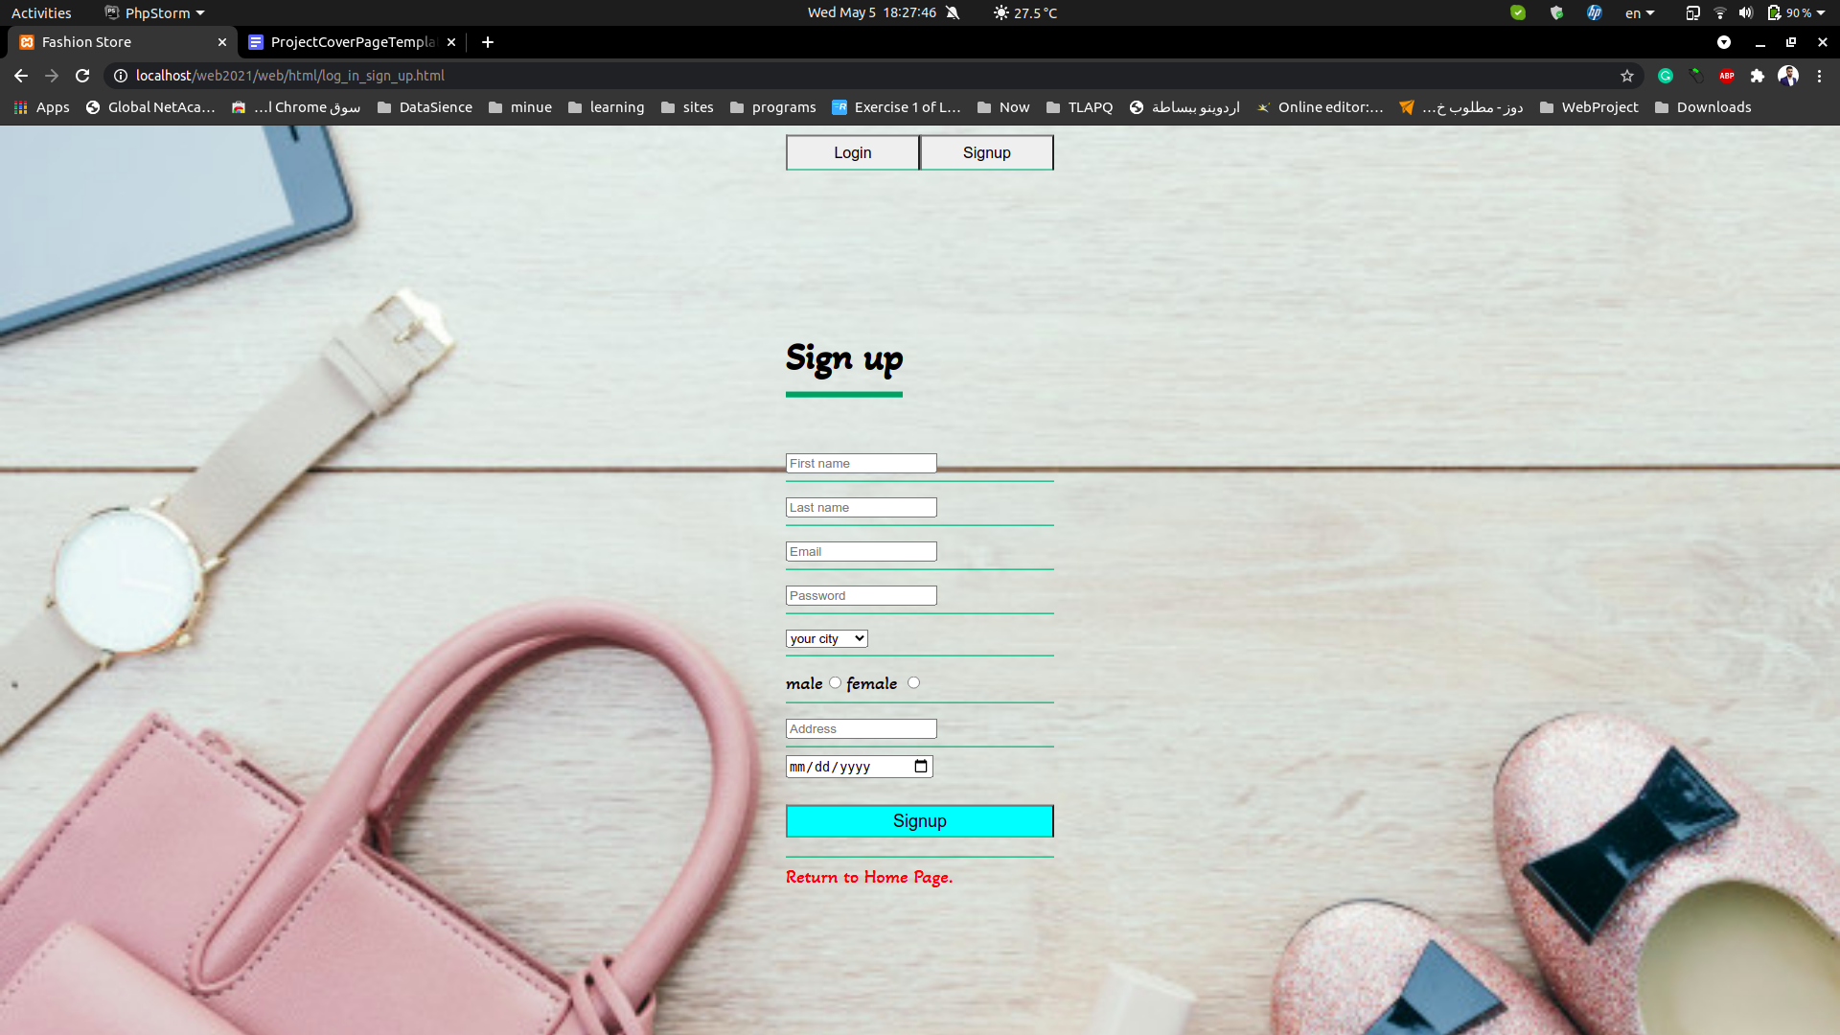

**If he put an exist email it will appears that there is an email exit**

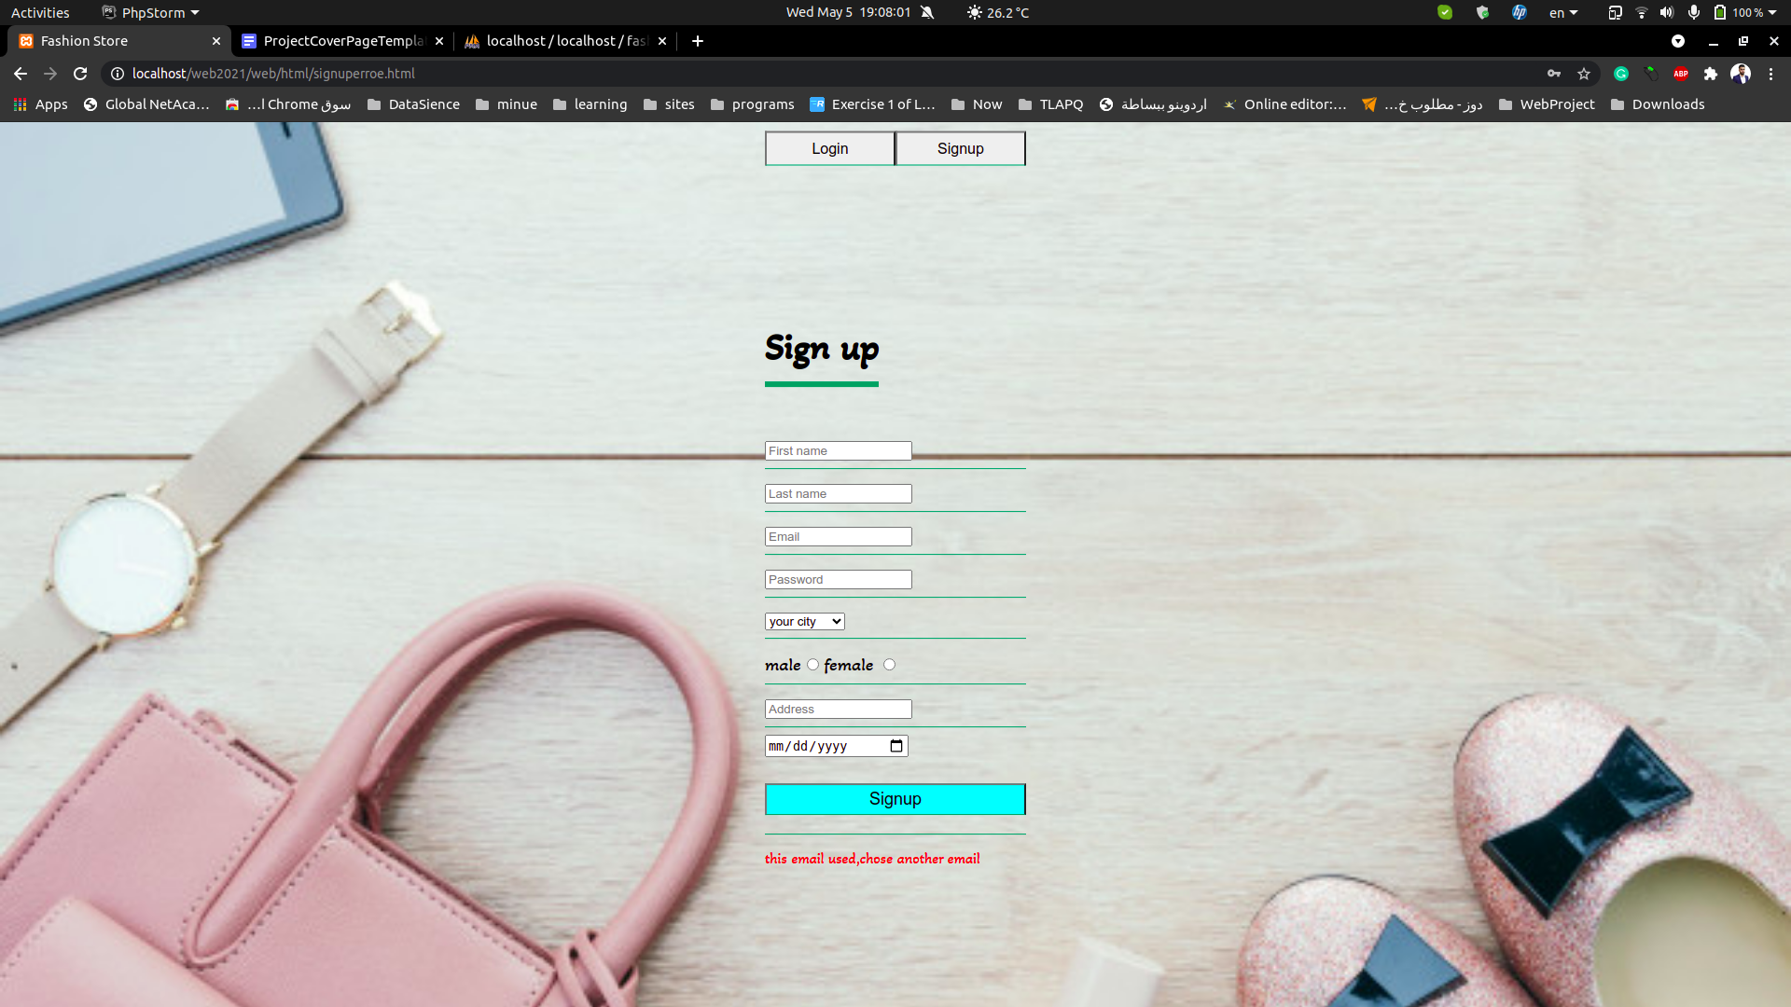

**If he already has an account he can go to the login and fill the email and password.**

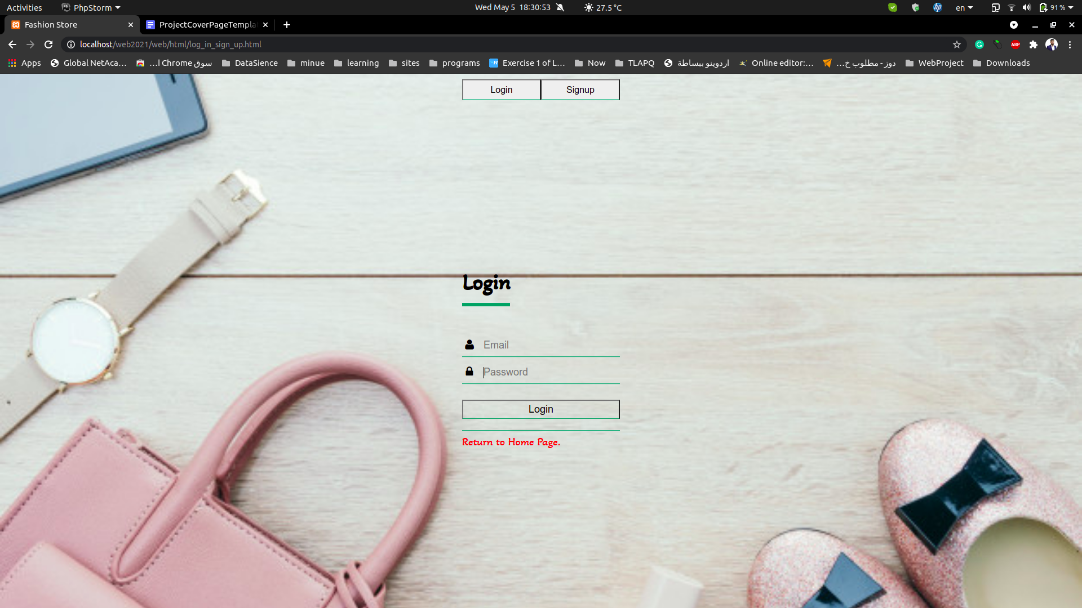

**If Don’t want to login he can return to the home page by click under login button in the red title(Return to the home page).**

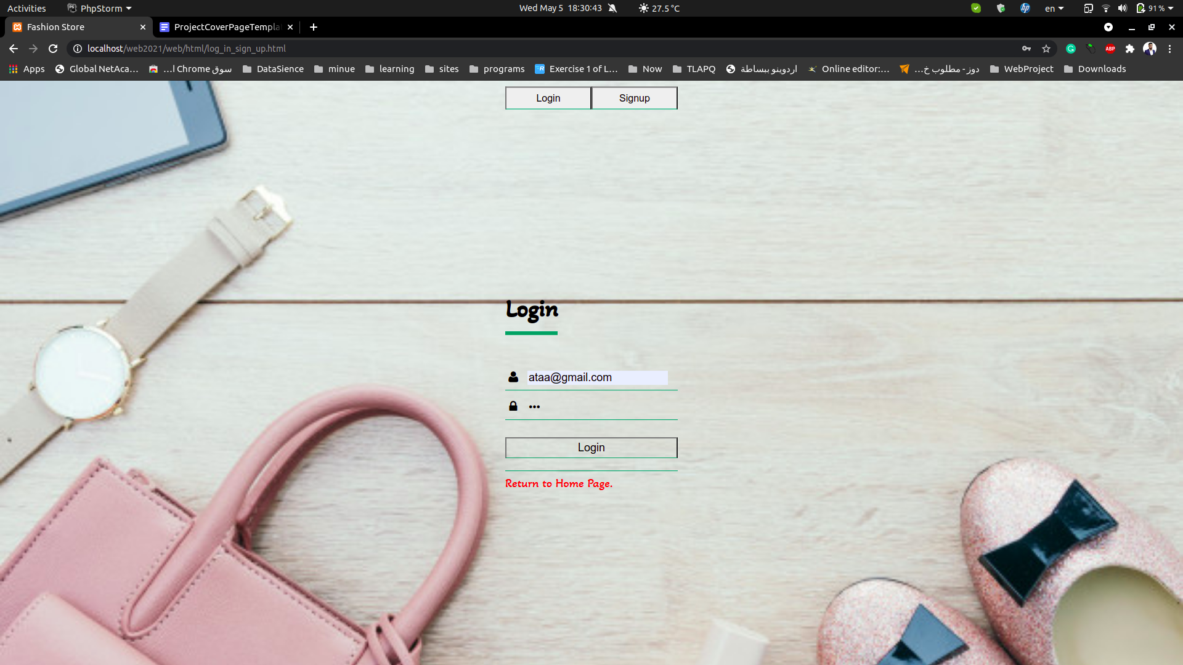

**If he puts the wrong email or password it will not make him logged in.**

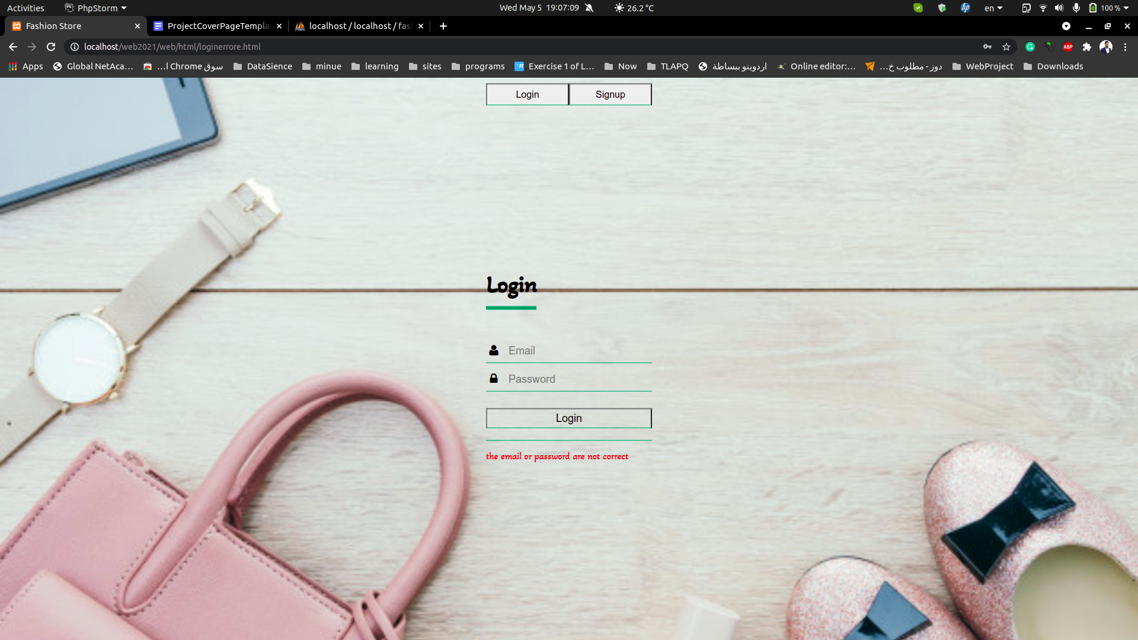

**if everything went fine it will transfer him to the home page as logged in.**

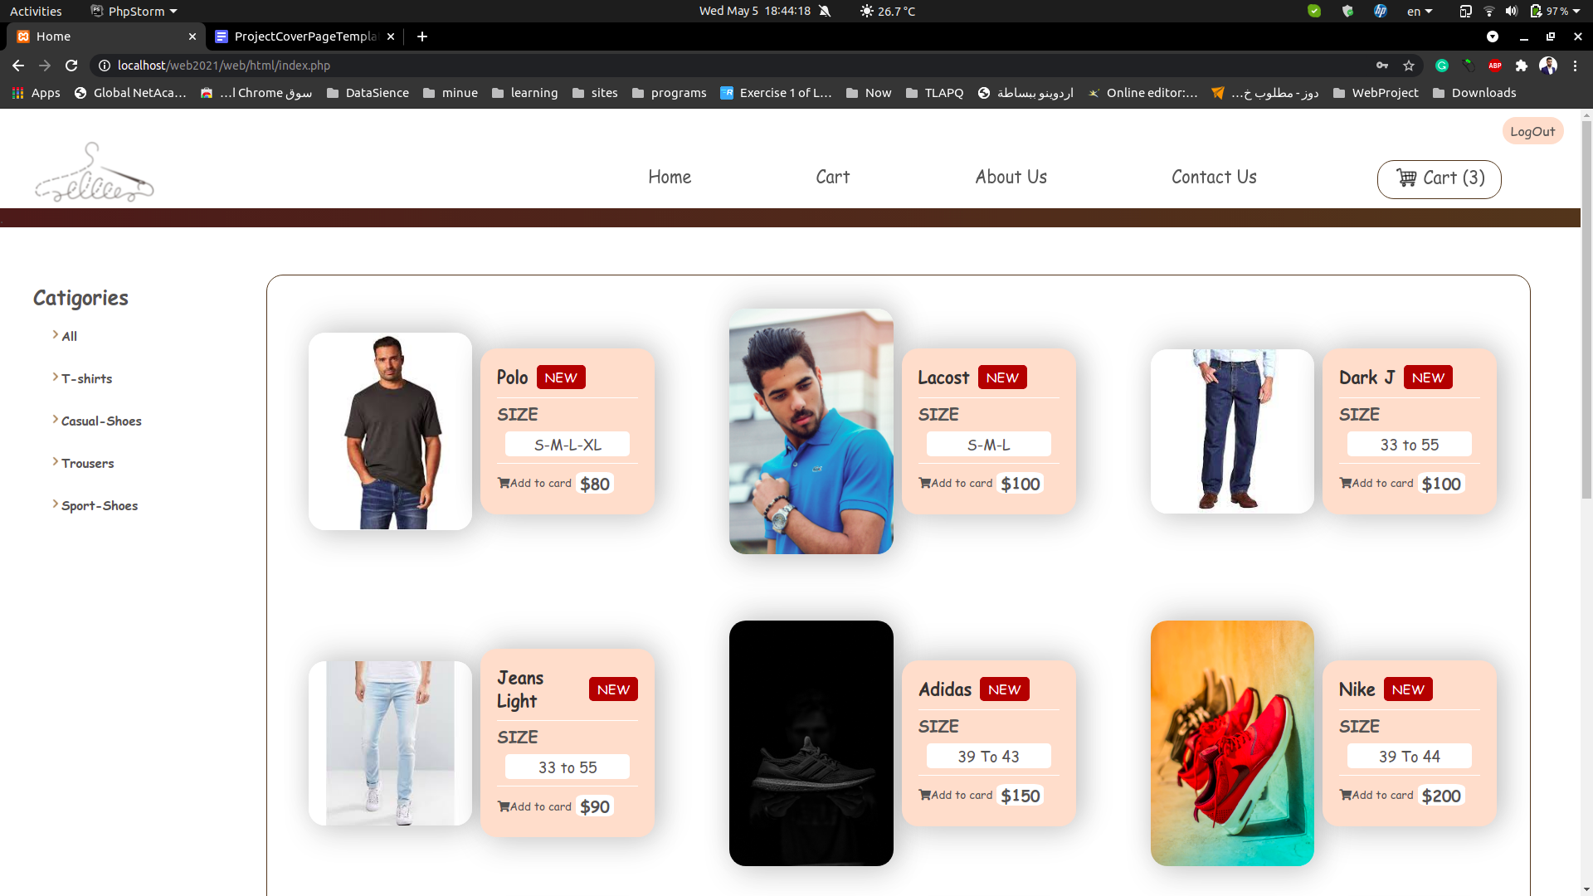

**Then, he can make the buy operation and it will clear the cart and it will send an order to the admin.**

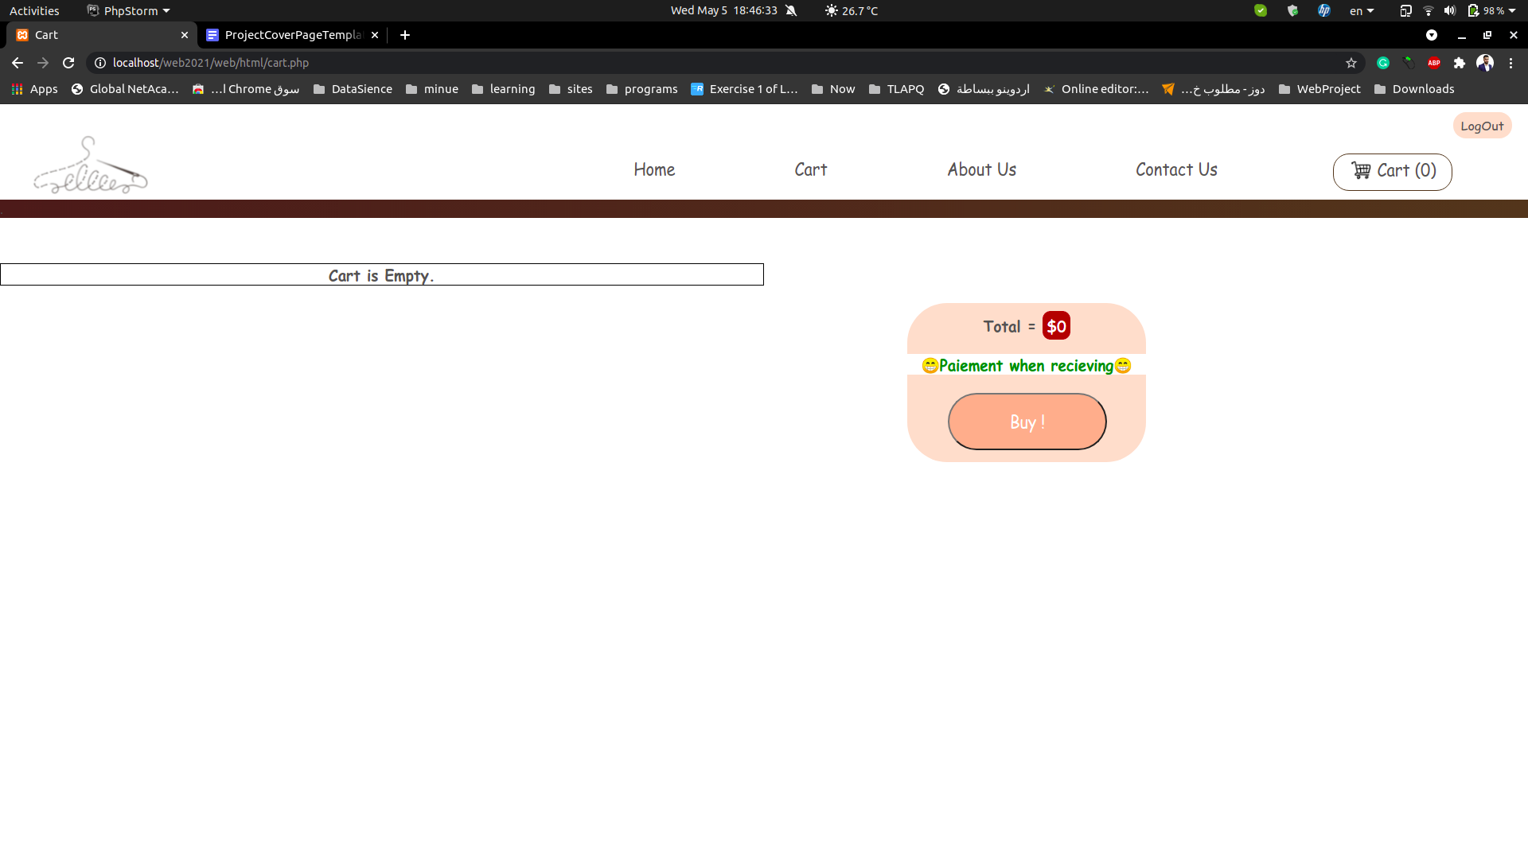

**If he wants to know about our shop he can go to the About Us page.**

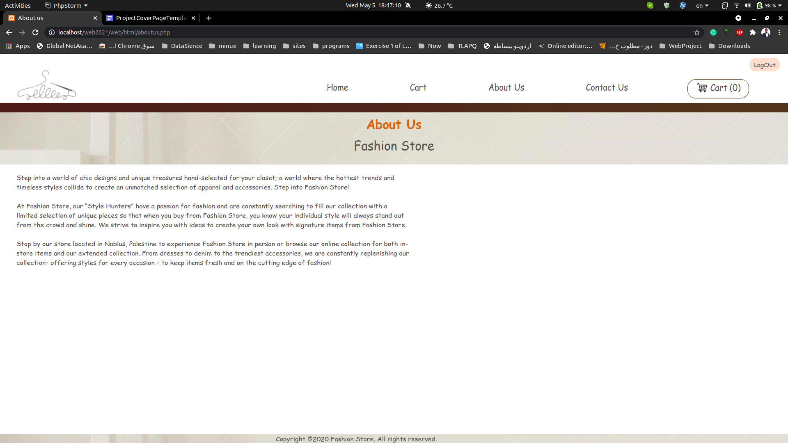

**If he wants to contact us and send feedback, he can go to the Contact Us page.**

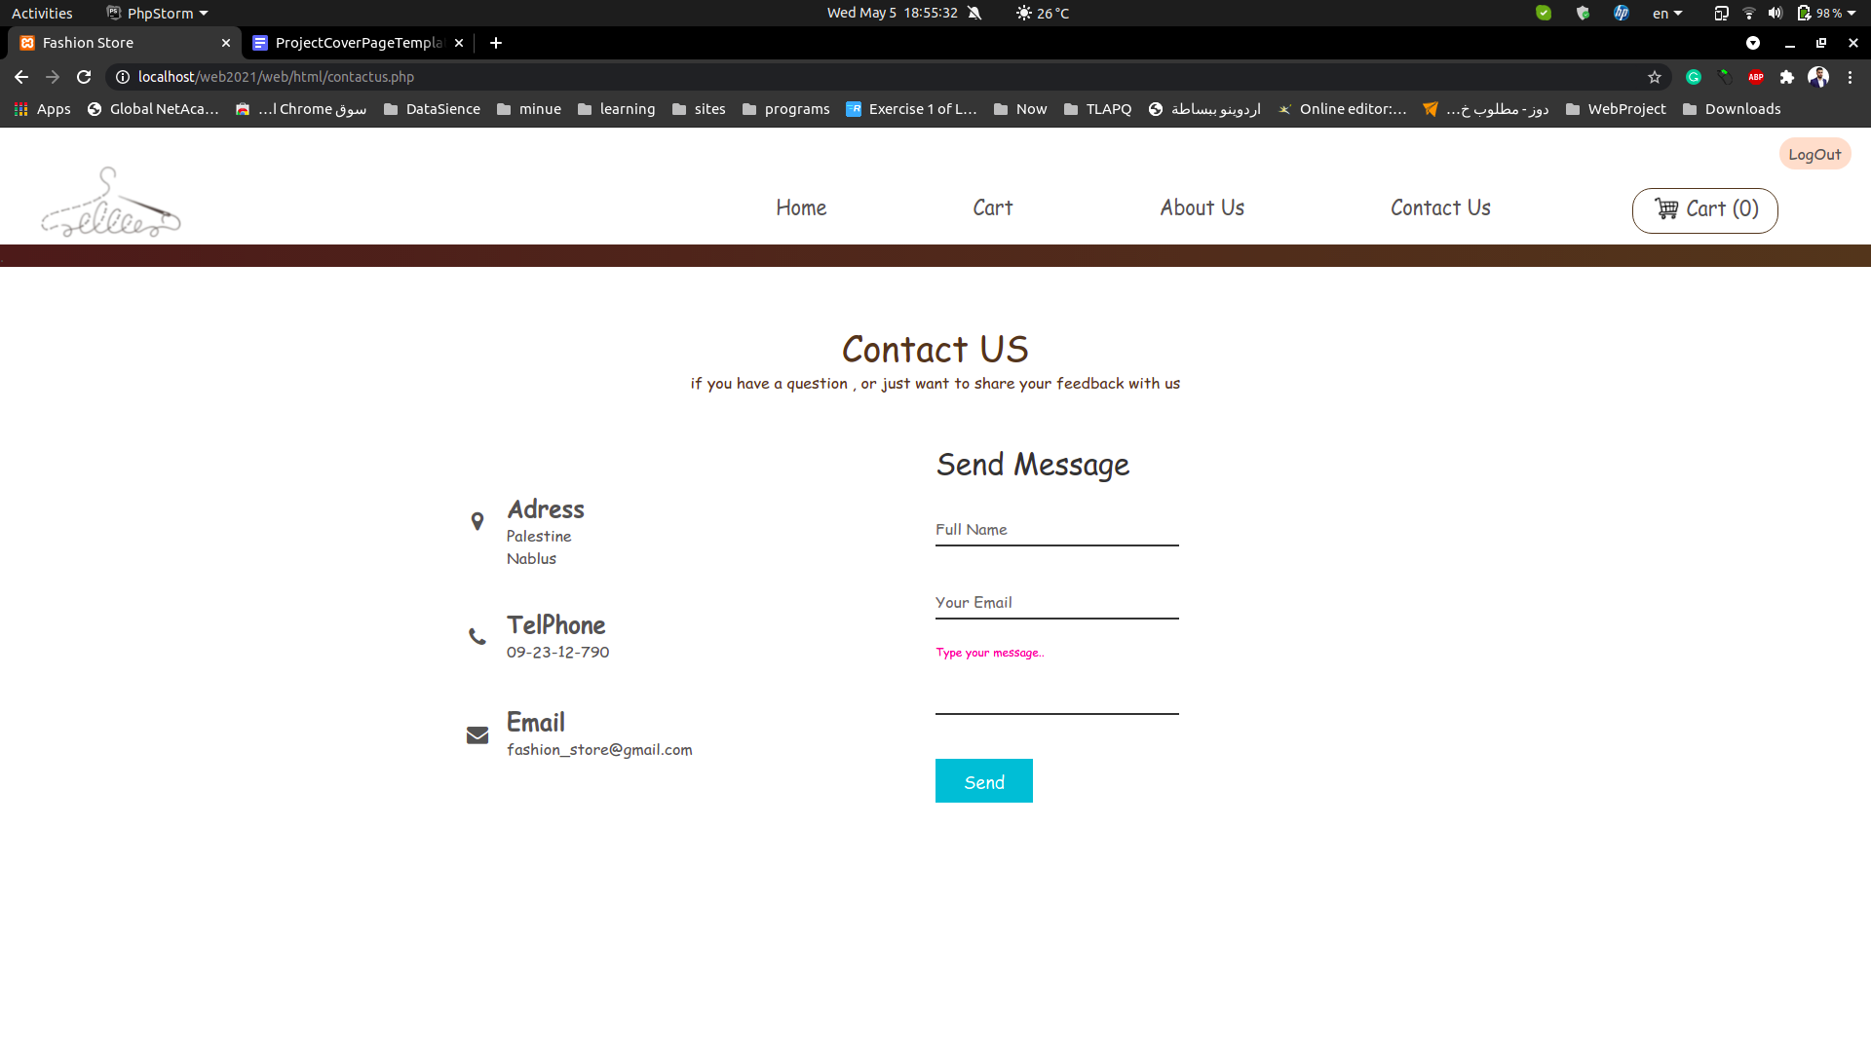

**And he can send feedback to the admins.**

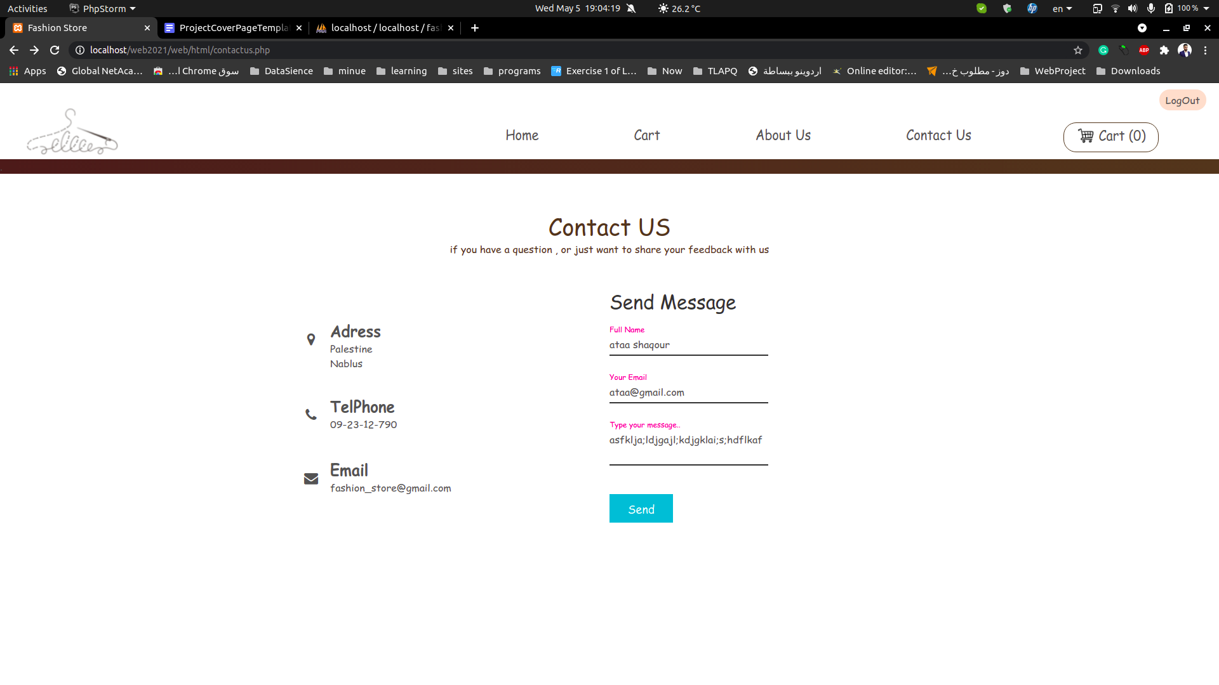

**ADMIN SIDE:**

**We added a specific email for the admin.**

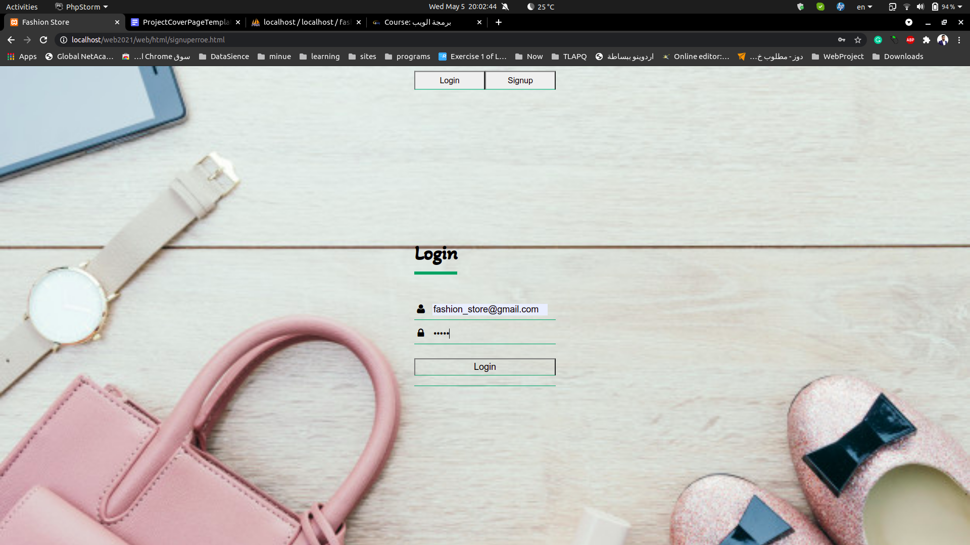

**When tha admin login, adminhome page appear.**

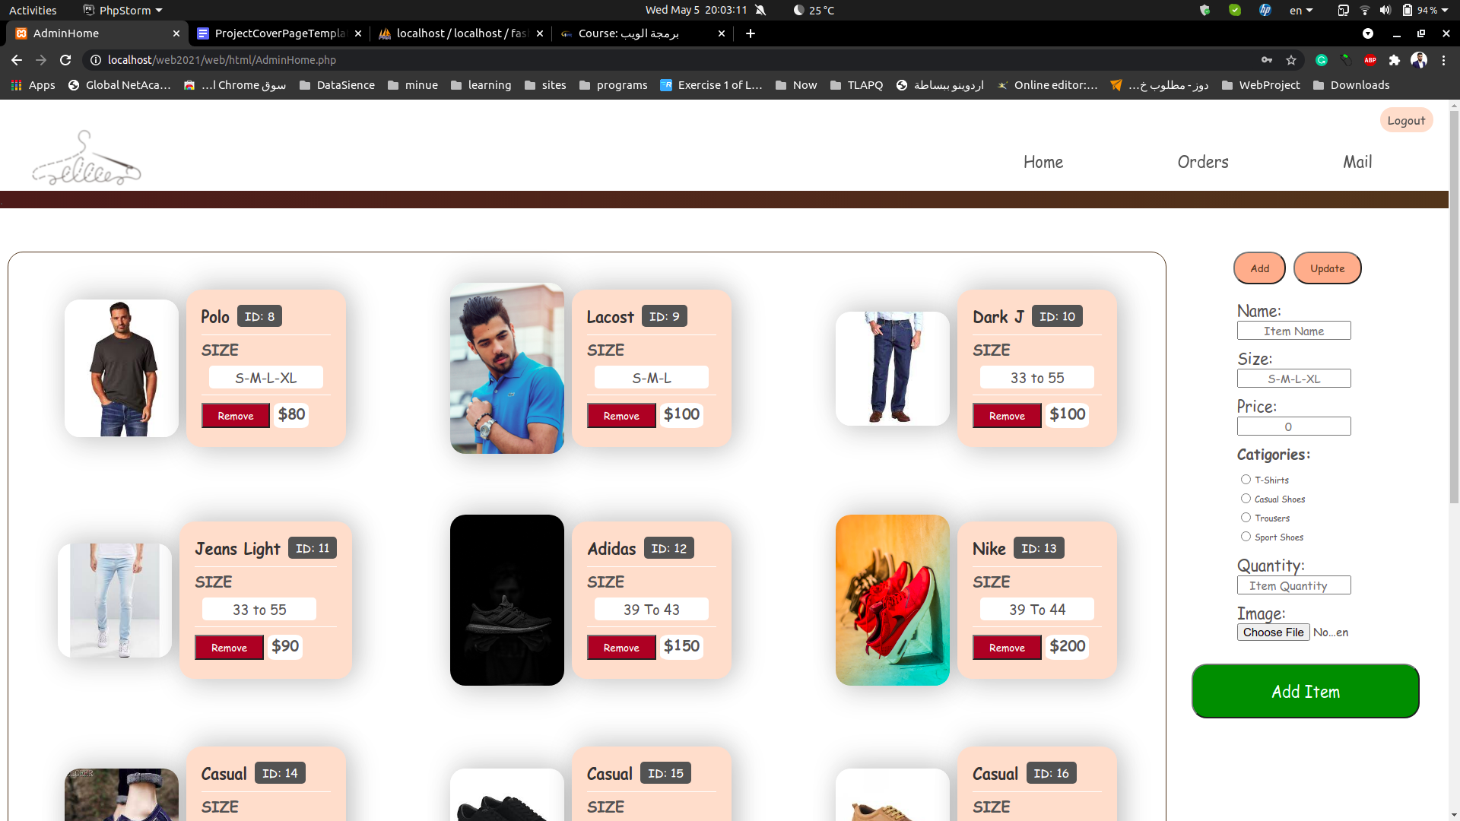

**Which contains a menu bar and items container and control side.**

**In the item container each item has a remove button which removes that item from the database.**

**In the control side, there is an Add button and Update button which make the admin to choose the action.**

**In Add action he can modify the name, size, price, category, quantity and the photo of the item.**

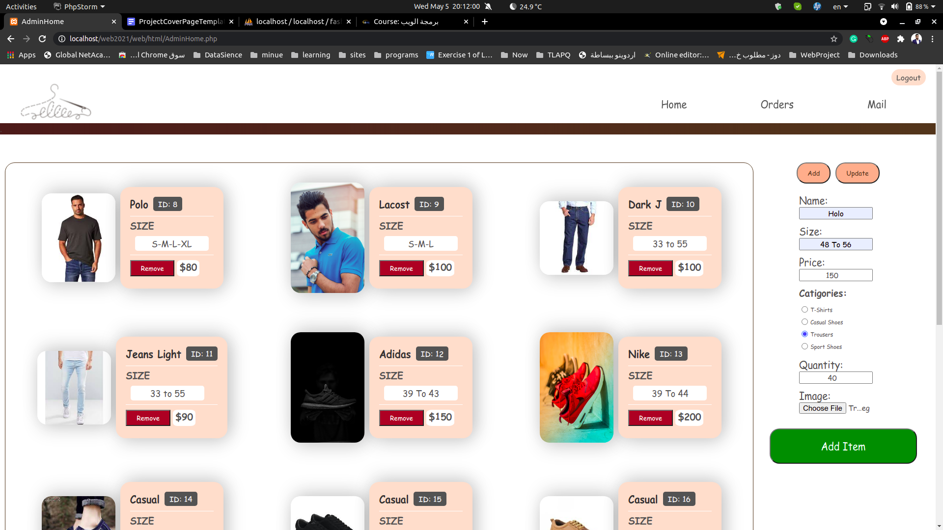

**After that, click in add Item to add it to data base.**

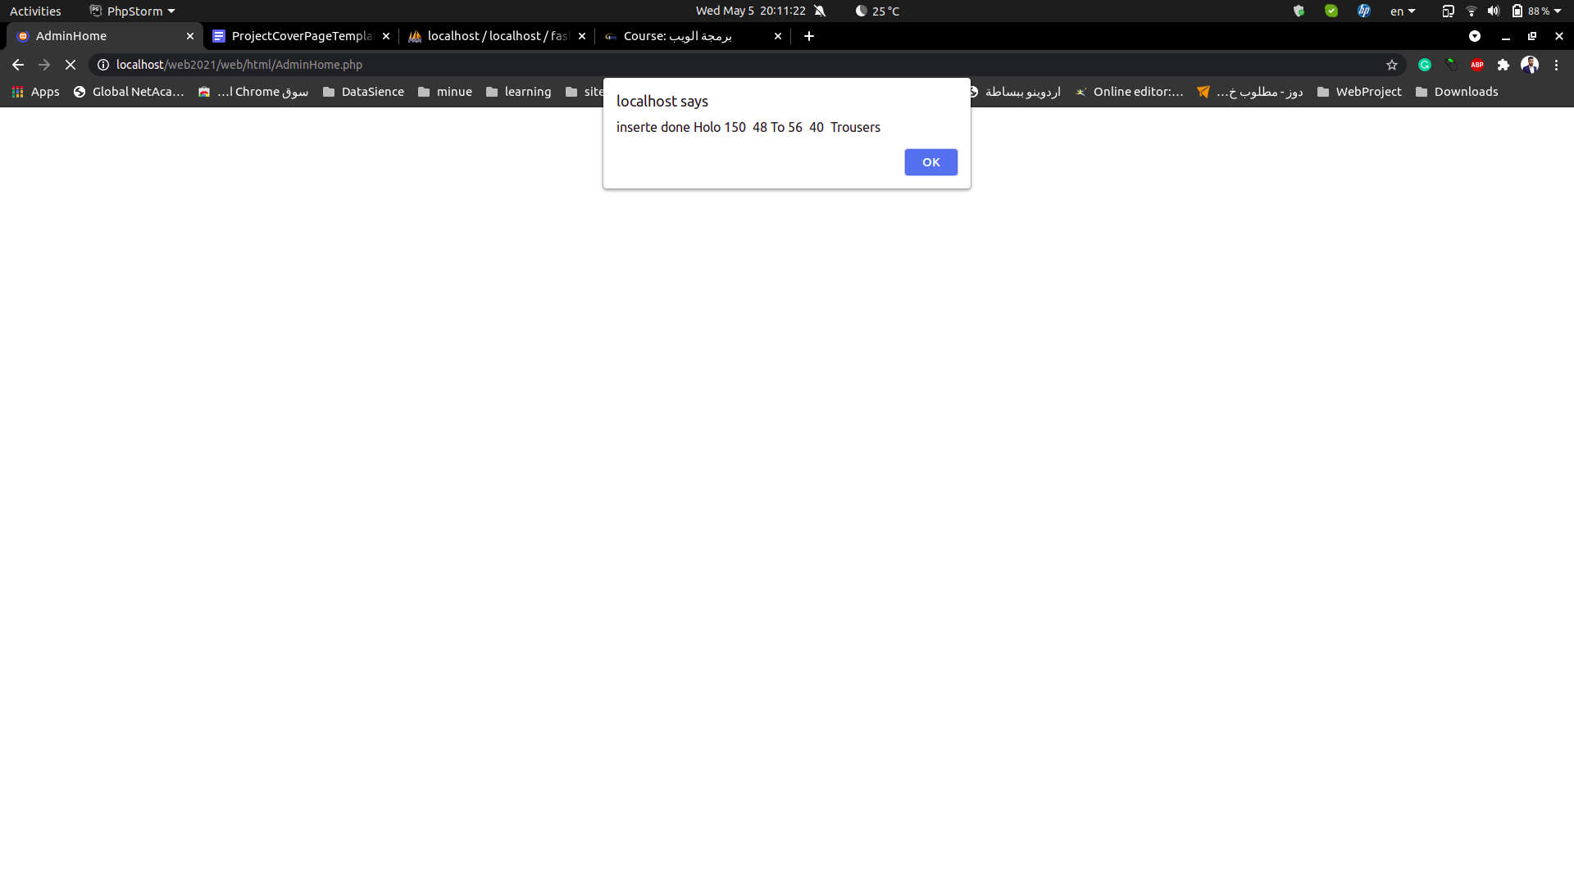

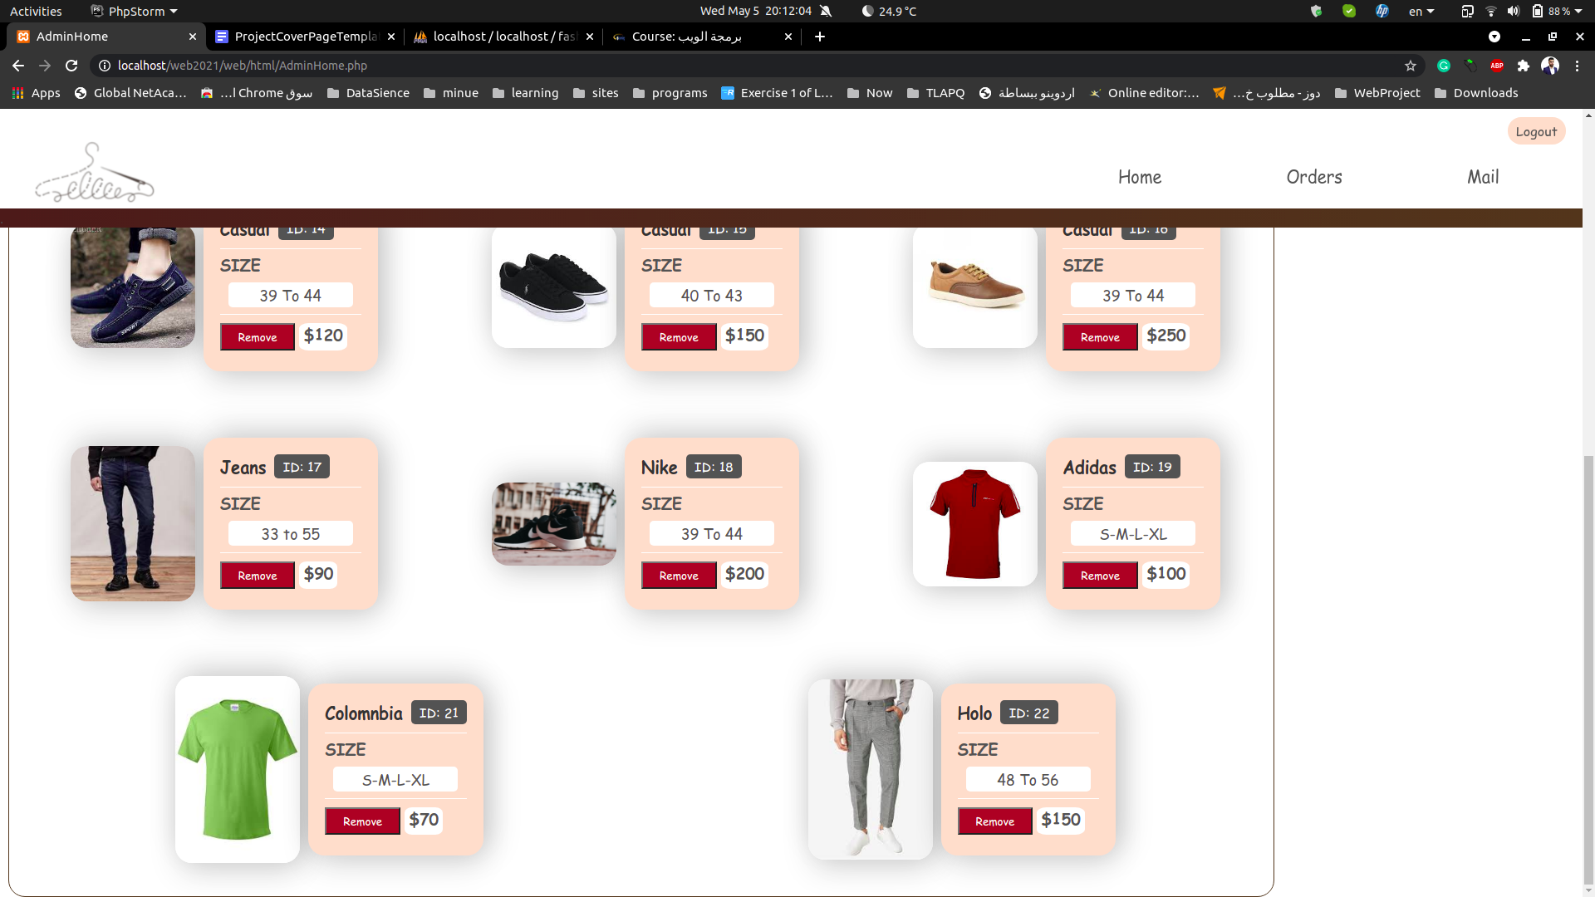

**So it added.**

**When he open the Orders page**

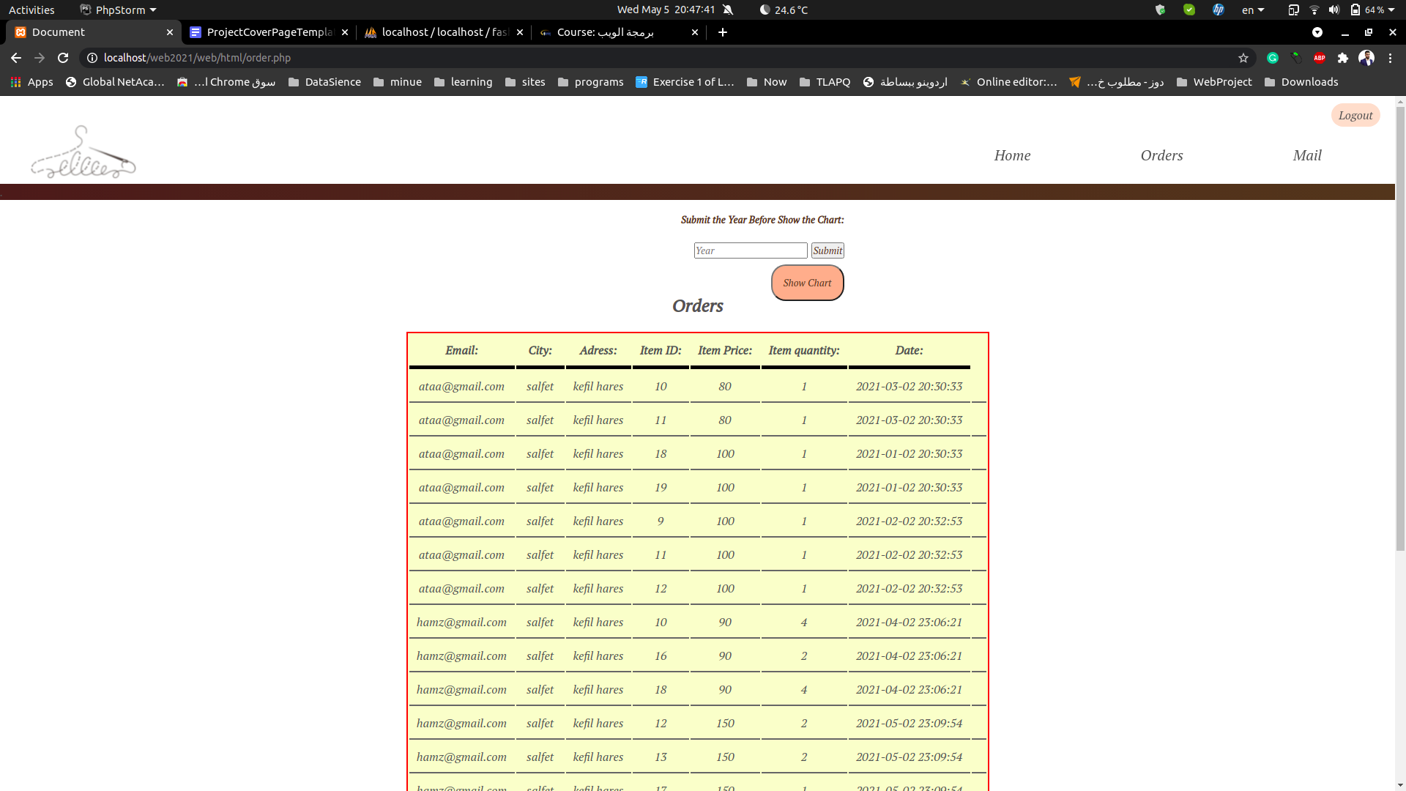

**These are the orders from the clients.**

**if the admin want to display how many sales per month in a specific year , he must inser the year then click on submit then click on show.**

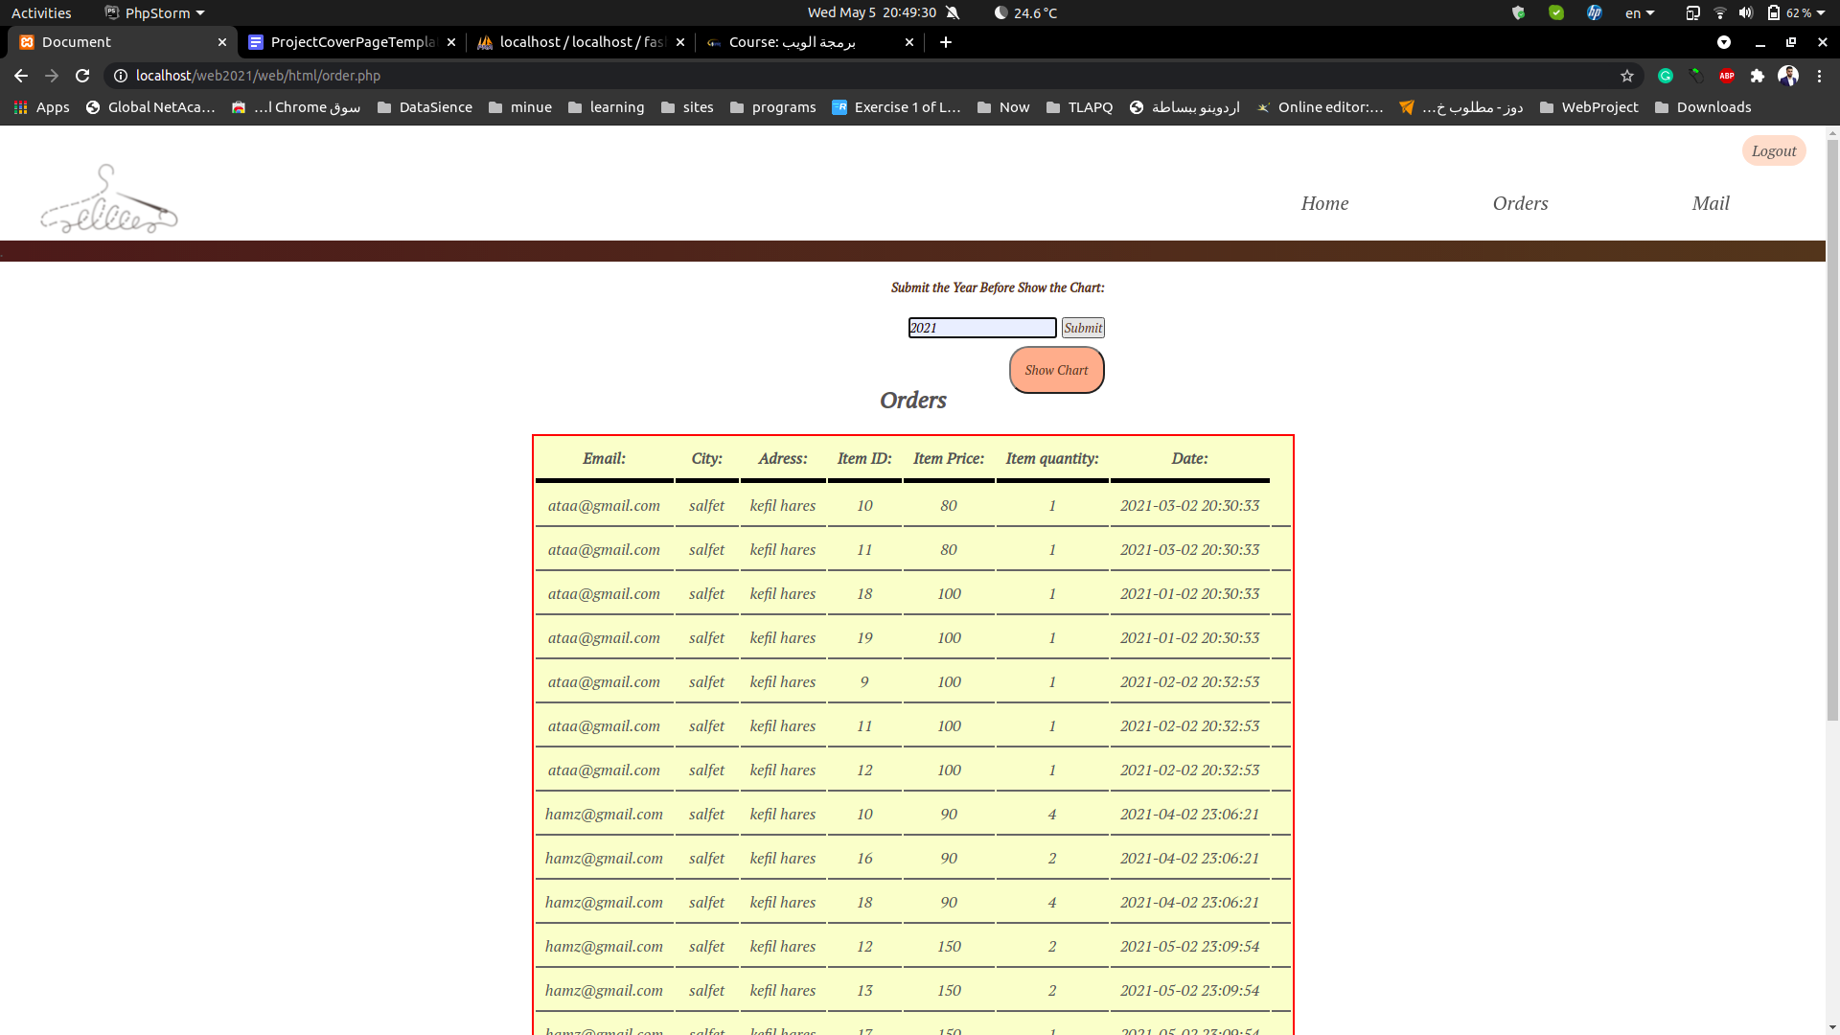

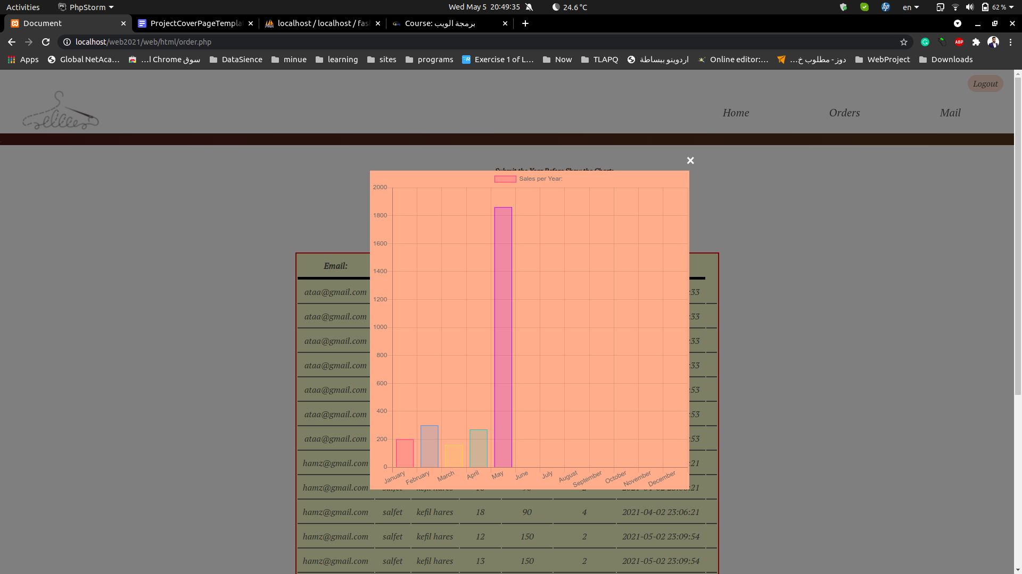

**So these are the amount of sales per month in 2021.**

**In the mail page, the admin can see the mails from the users.**

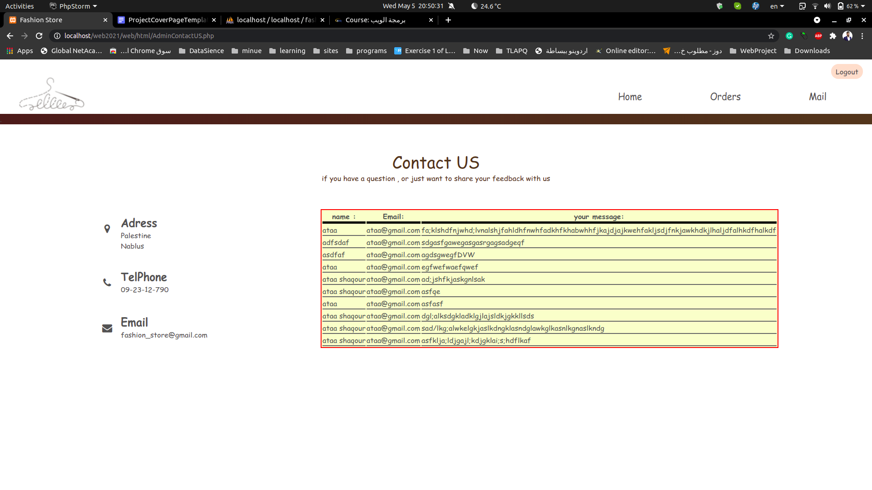

**Finally, when he finished, he can click on logout and it transfer him to the sign in page.**

**Conclusion:**

In the end, we have succeeded in facilitating online shopping for users and we have succeeded in saving time and effort on the human being, so he can know what he wants about the store and the available products while he is sitting at his home.

On the one hand of the store manager, the website works to spread the store and increase its sales

**References:**

Stack overflow:<https://stackoverflow.com/>

YouTube:<https://www.youtube.com/>

W3school : <https://www.w3schools.com/>

Php documentation: <https://www.php.net/>

Dr.Sufian Samara’s lectures.